Sonar Qube :

Name: M.Witty

Roll No: 2420030759
To perform static code analysis on a simple java program using sonarqube and identify code quality issues such as bugs, code smells, and maintainability
Step 1: Install SonarQube and SonarScanner
https://www.sonarsource.com/products/sonarqube/downloads/
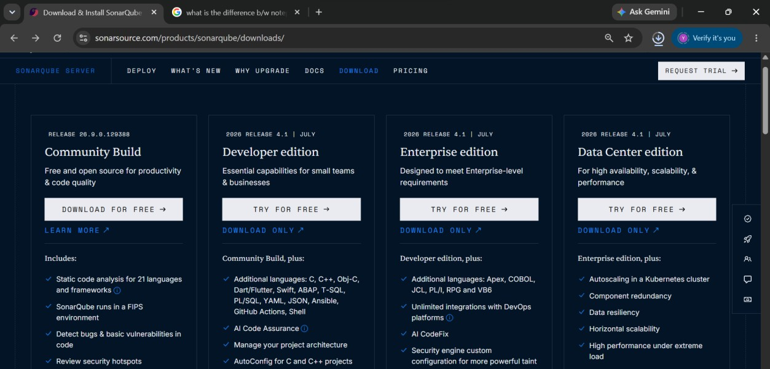
Step 2: Goto C Drive-> Open the SonarQube Folder->Open the bin Folder->Open windows-> Choose the OS-> Open

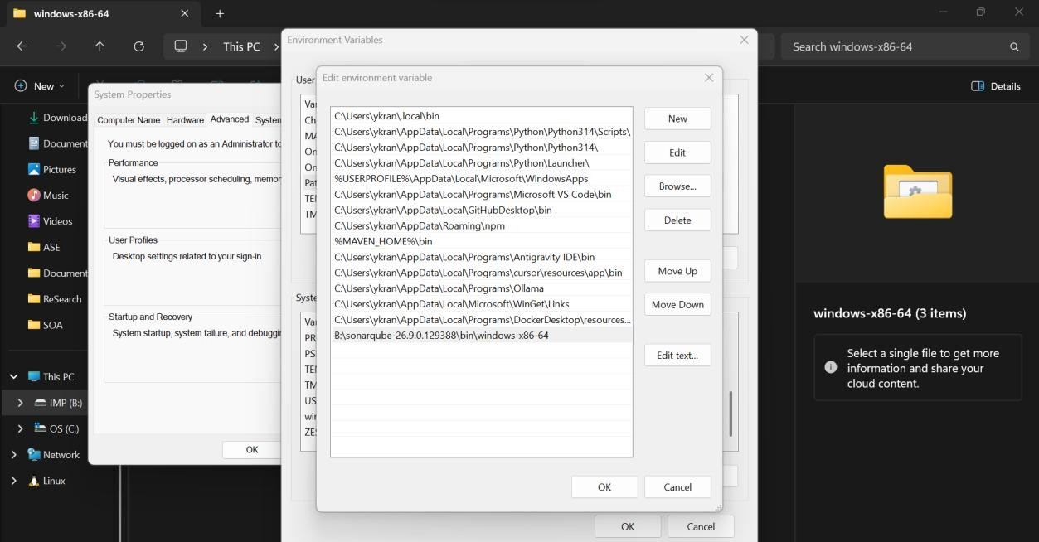
Windows Folder
Step 3: Goto windows open the Edit system Environmental Variables-> select the path -> Edit-> click on New-> Paste the path -> click on Ok , Ok and Ok
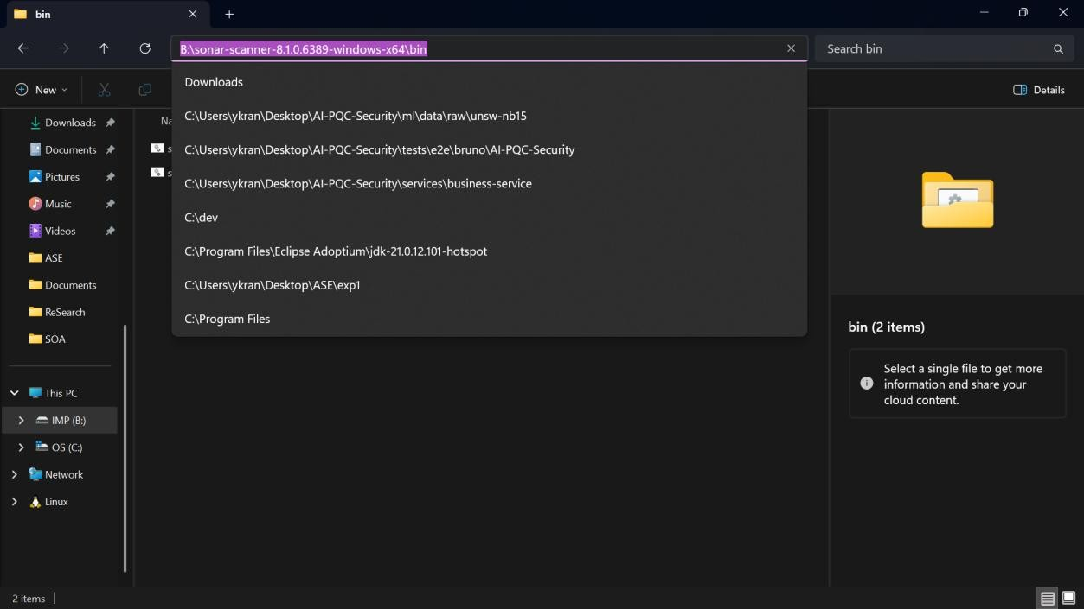

Step 4 : Install SonarScanner
https://docs.sonarsource.com/sonarqube-server/9.9/analyzing-source-code/scanners/sonarscanner

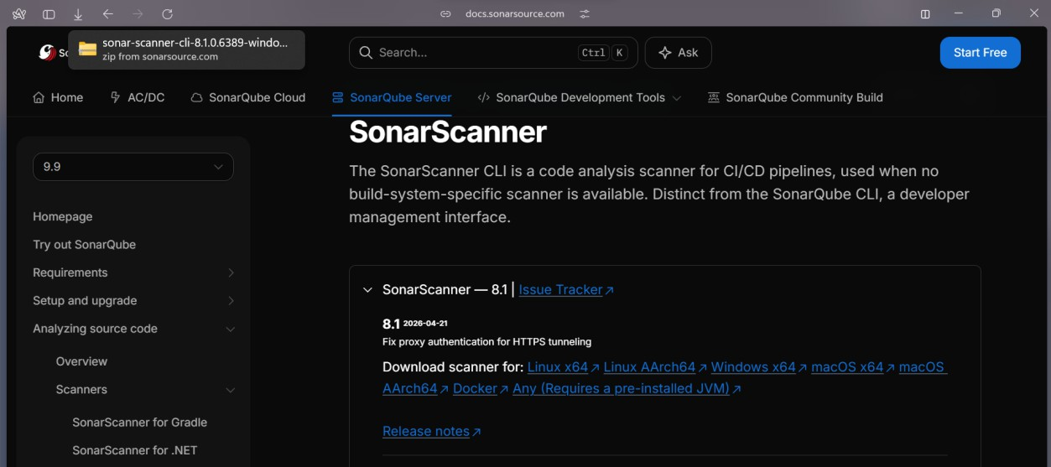
Click on SonarScanner – 8.1 | Issue Tracker

Step5 : Goto C Drive-> Open the sonar-scanner Folder-> Open the bin Folder-> Copy the Path and add the path to system environmental Variables
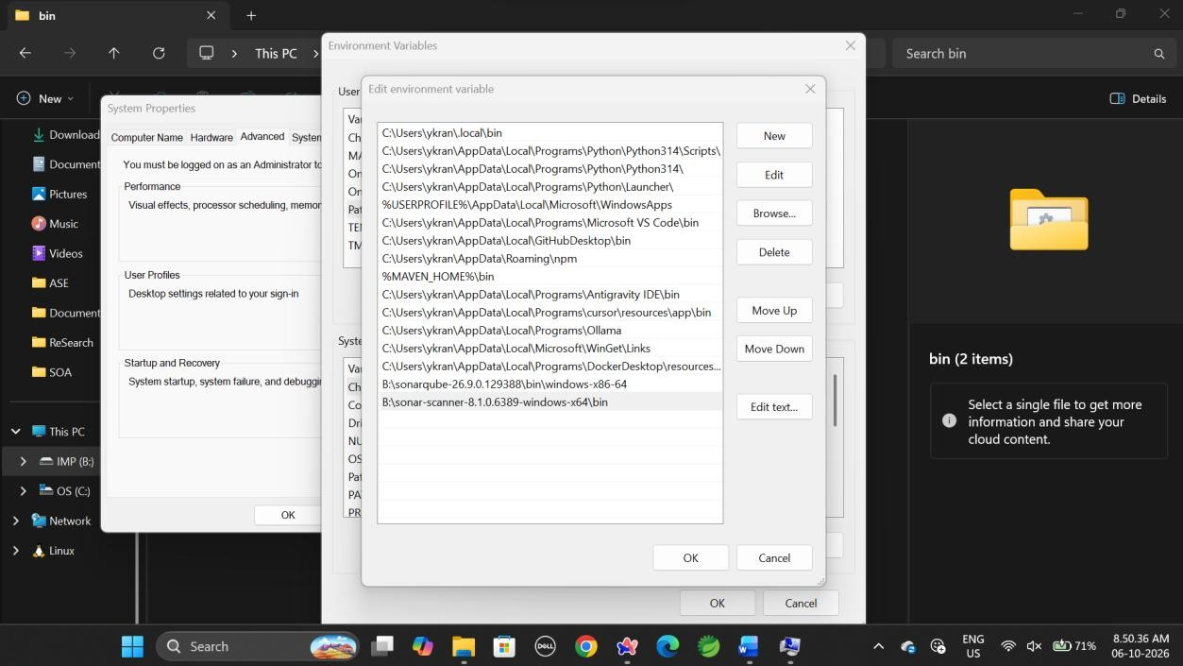
Step6 : Open the cmd type the command “StartSonar”

we should get Process[ce] is up SonarQube is operational

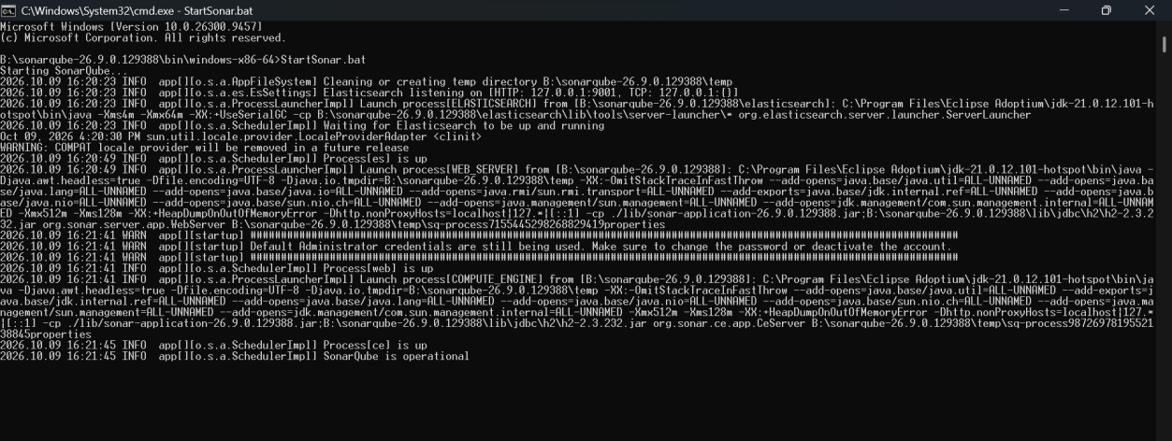

we should not close the command prompt of the SonarQube. We have to minimize. Because it will ShutDown
Step7: Open the browser and type localhost:9000 and press enter
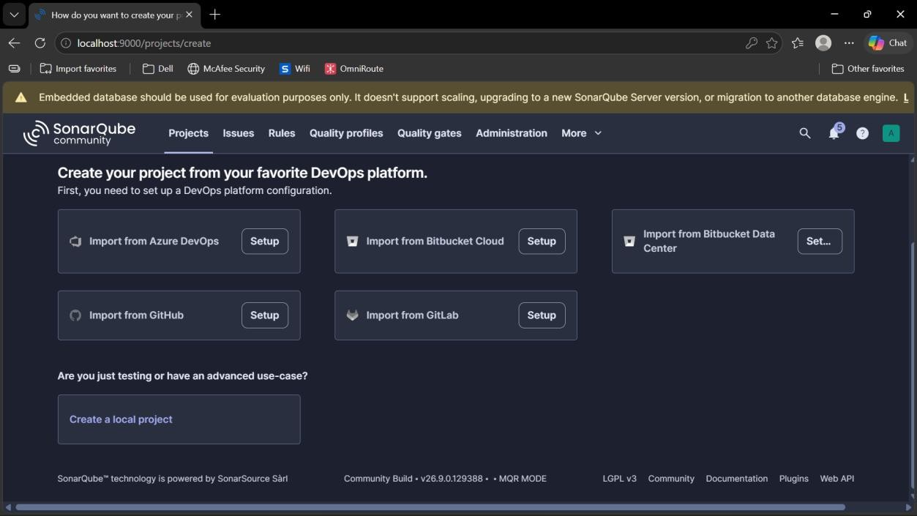
Username and Password -> “admin”
Step8: After entering
Click on create a Local Project
Step9: Enter the project Name and click on Next After enter Project Name and Project Key

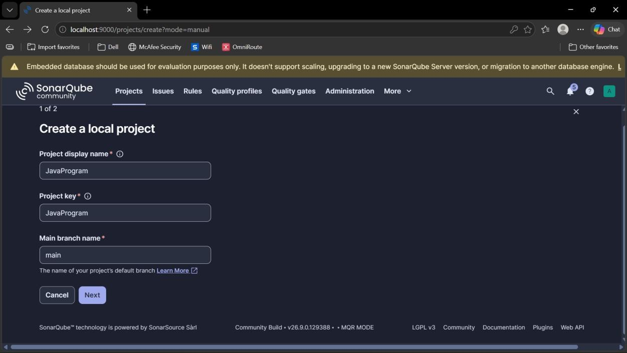
after clicking next we will get
“Follows the Instances default” Click on create Project
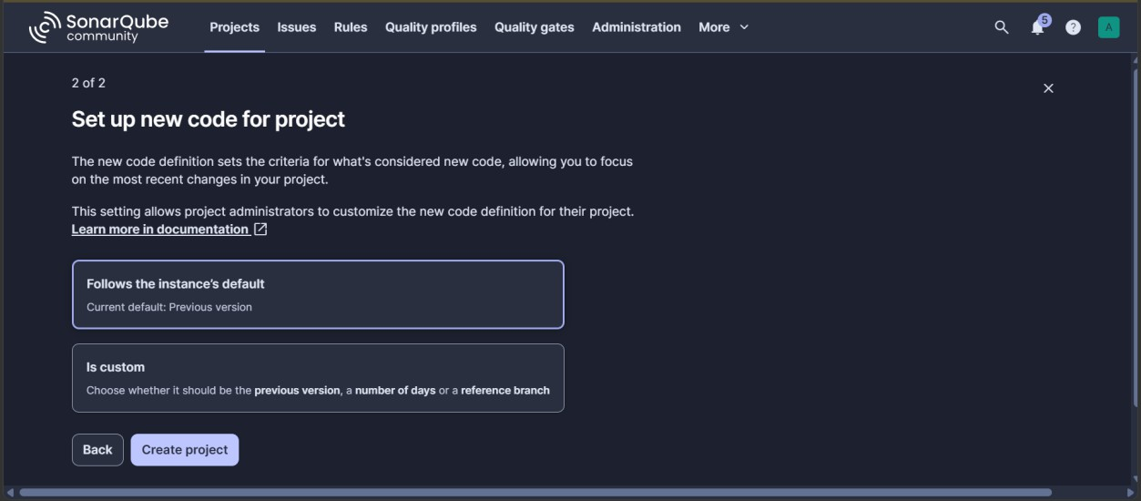

Choose “Locally”
Click on “Generate”

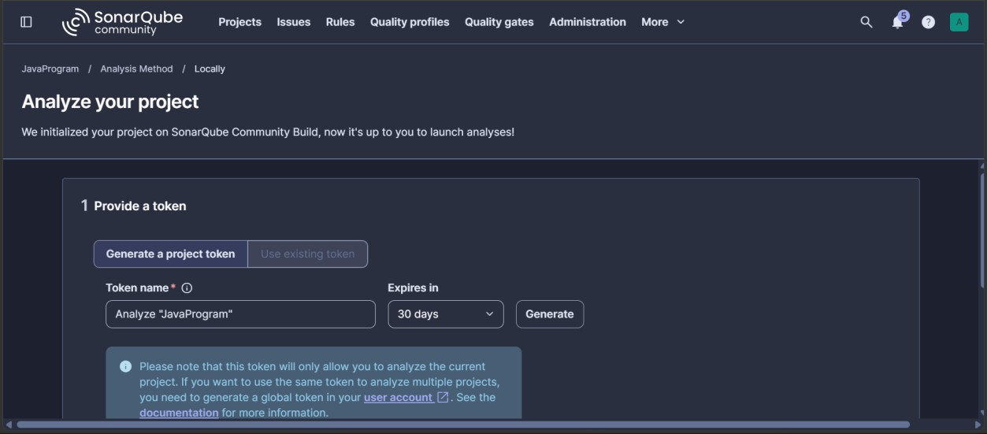
then we will get a “TOKEN”
Copy that token and paste it anywhere

Step 10: Open new cmd as in the previous cmd is in Operational of SonarCube
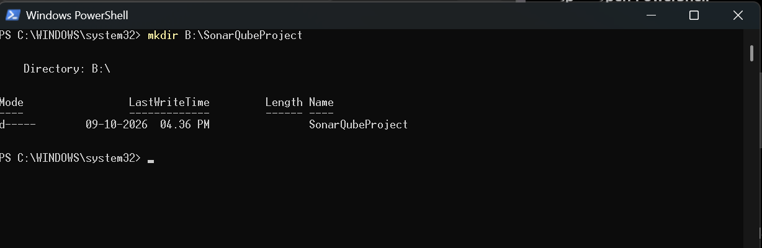
Enter -> sonar-scanner -v
Step 11: Configuration File Should be named as “JavaProgram”

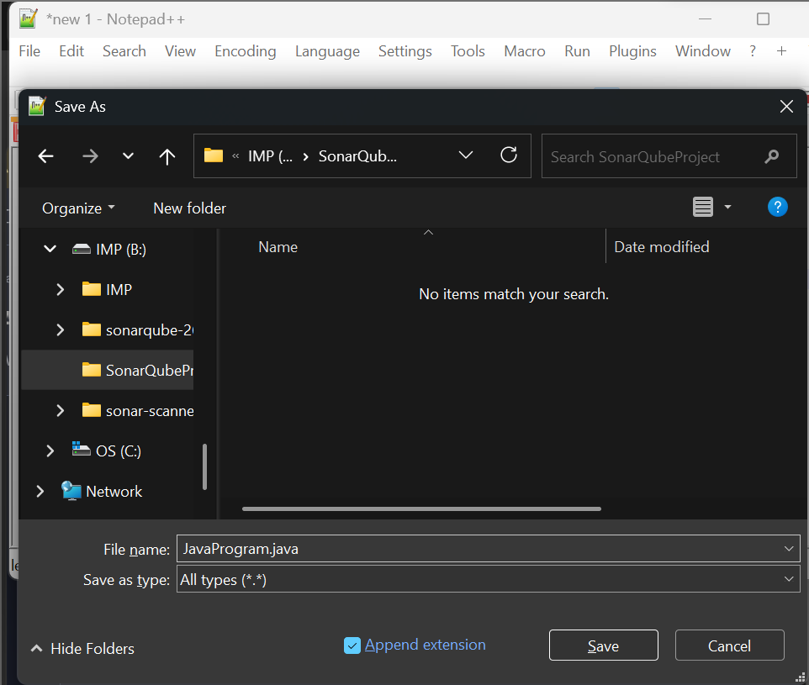
Step 12: compile the JavaProgram to get the class file copy the path where java program is saved
Change the directory where the program is there goto cmd and change the path

cd C:/SonarQube

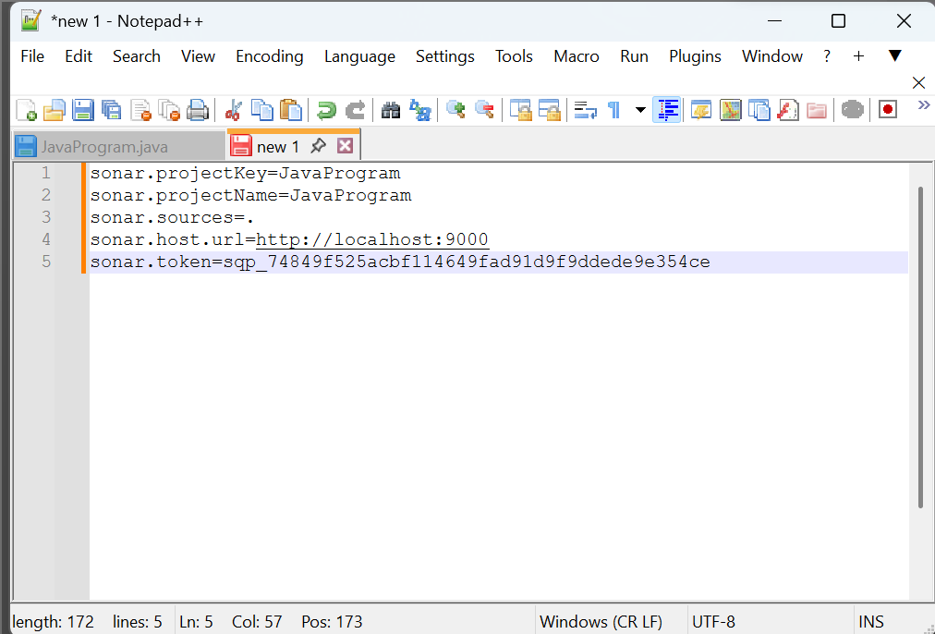

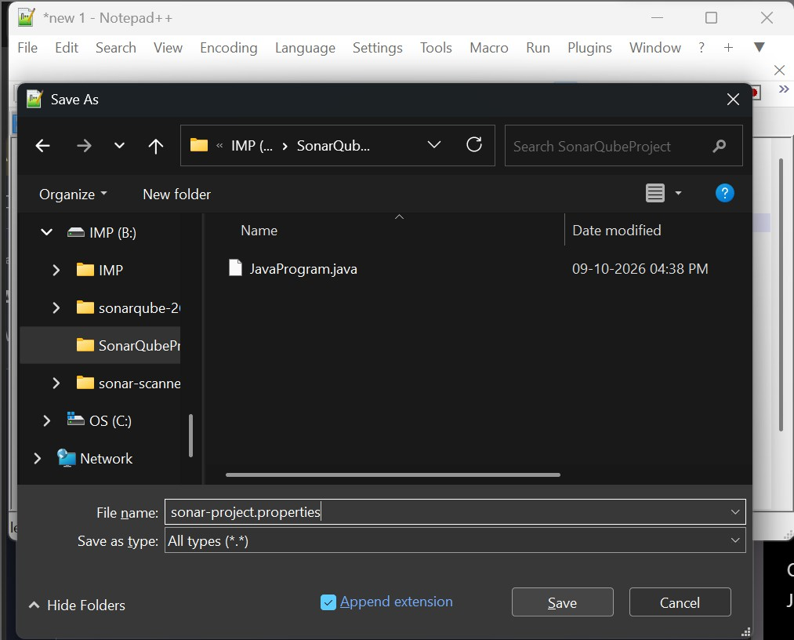
Step 13: compile the program in the cmd

C:\javac JavaProgram.java
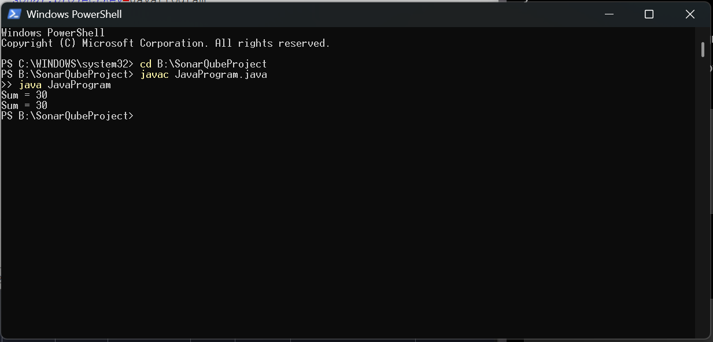
Step 14: Scan the program cmd-> sonar-scanner
Once the scanning has done you will get as “EXECUTION SUCCESS”

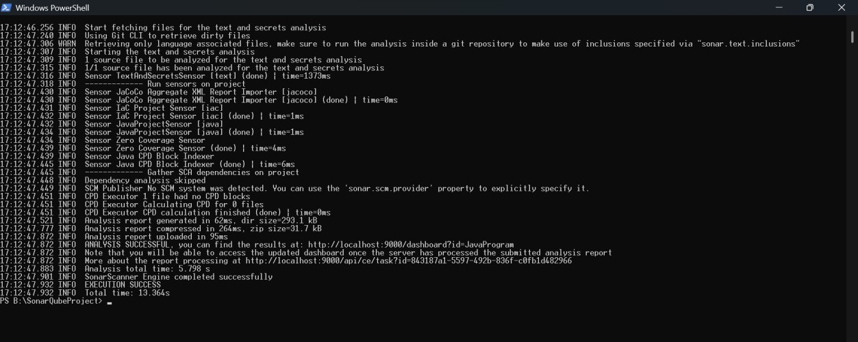
Now goto the Server Report will generate Open the SonarQube Browser

Step 15: Click on Projects on top and check the report
Here 5 Maintainability is showing check those click on issues it will give all issues
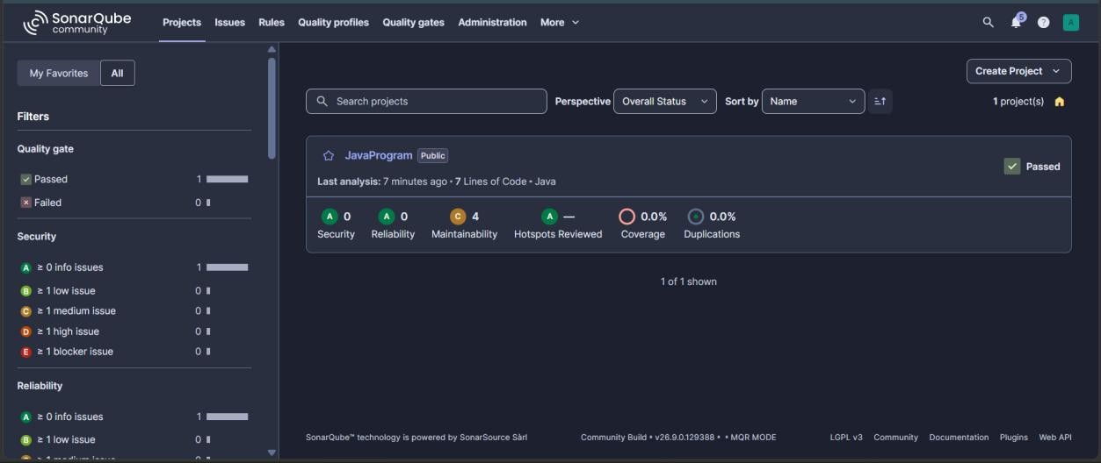

Server is in Operational, once the work is done stop the server Open the cmd where the server is in operational

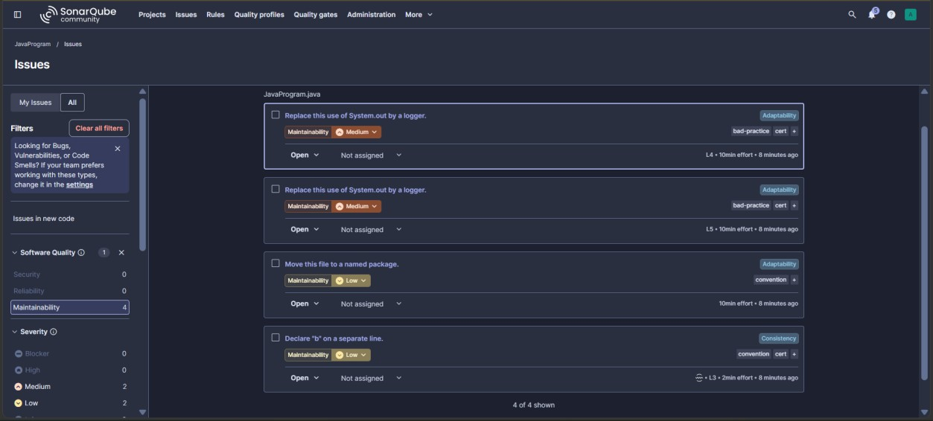
Press ctrl+c

Type exit and y
To Check the server is stopped, open the web browser of SonarQube and refresh.

